# Oracle Database 23ai R2 SQL -

# Installation & Setup Guide

This document provides a complete, step-by-step guide to setting up Oracle Database 23ai R2 SQL using Oracle Linux inside a VirtualBox VM. It includes installation of the Linux OS, Oracle 23c Free, and SQL Developer for development.

## Manual Installation of Oracle 23ai R2 SQL on Oracle Linux VM

Note: Oracle 23c Free is only supported on Linux OS.

### Step 1: Install Oracle VM VirtualBox

* Download from: https://www.virtualbox.org/
* Complete the installation process.
* 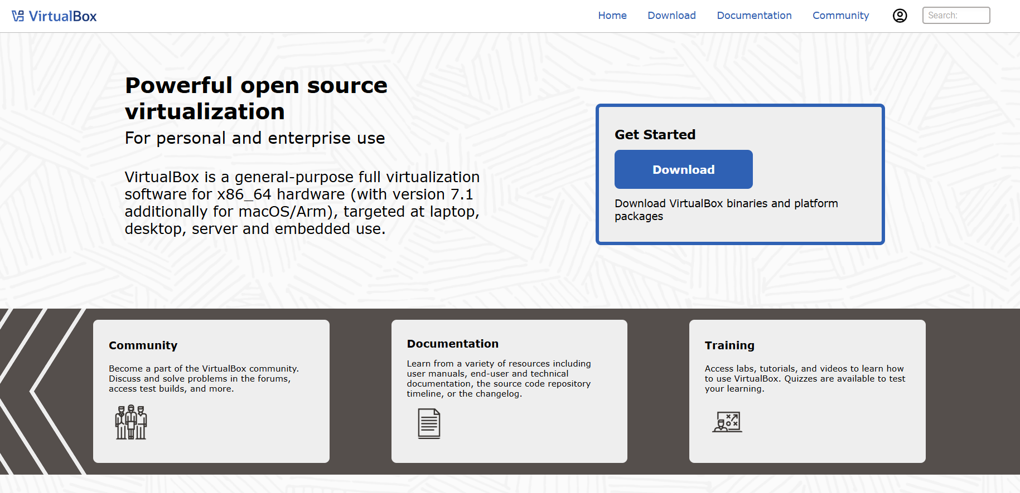

### Step 2: Download Oracle Linux ISO

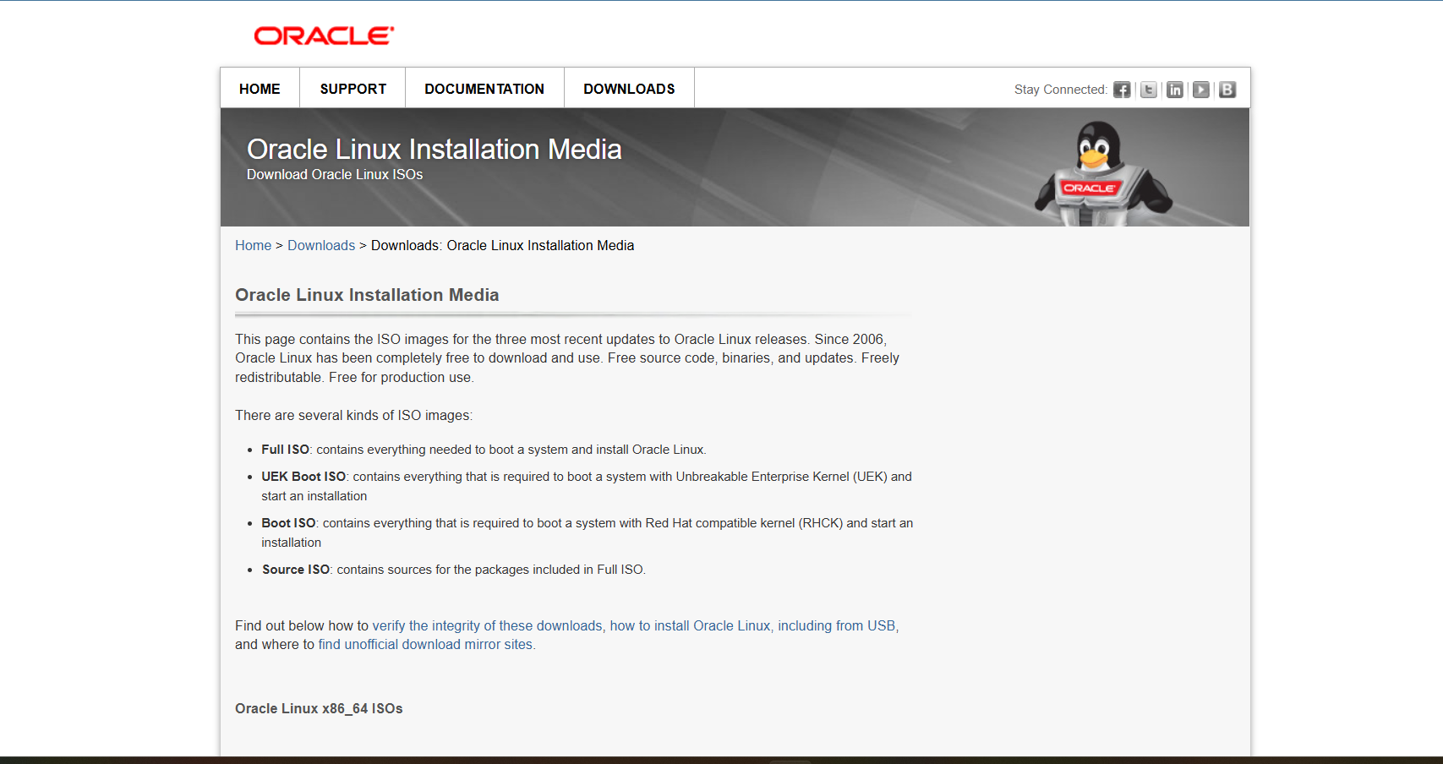

* Visit: https://edelivery.oracle.com/osdc/faces/Home.jspx
* Download the latest Oracle Linux ISO.

### Step 3: Create Linux VM in VirtualBox

* Name: OracleLinux
* Type: Linux
* Version: Oracle (64-bit)
* Memory: Minimum 2 GB
* Hard disk: Minimum 20 GB
* 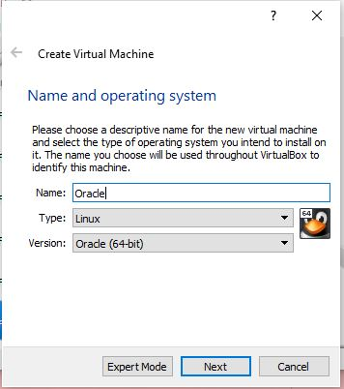

### Step 4: Install Oracle Linux

* Boot the VM using the Oracle Linux ISO.
* Follow the installer instructions to complete OS installation.

### Step 5: Install Oracle 23c Free

* Inside the Linux VM, open a terminal and run:
* sudo dnf -y install oracle-database-preinstall-23c
* sudo dnf -y localinstall oracle-database-free-23c.x86_64.rpm
* sudo /etc/init.d/oracle-free-23c configure
* Note down the system passwords and DB name shown in the output.

## ****Step 6: Verify Installation****

**Check Database Status:**

Run the following command to verify that the database is running:

**Connect to Database**



THANK YOU